
DEPLOYMENT GUIDE

1. implementing the chat 2
1.1. Uploading the files and creating the database 2
1.2. Chat settings 2
2. making the chat available to the client 2
3. ERM – ENTITY RELATIONSHIP MODEL 4
4. translating into other languages 5
5. SYSTEM REQUIREMENTS 5
6. STANDARD USER ACCESS 5
7. CHANGING PARAMETERS (DB) 6

1. implementing the chat

1.1. Uploading the files and creating the database

First upload the "chat" folder to the server. For example, if you have a http://www.my-website.com.br domain and puts the "chat" folder in the root, the communication input address with the support will be http://www.my-website.com.br/chat and you can use a JavaScript function to open the address from your website as shown at item 2 of this document. (Also take a look at item 1.2 to perform the settings if you want to do this before uploading the files)

Then run the database script located within the "docs" folder named "tables.sql" and optionally run the file "trigger_chat_au.sql" to send an automatic welcome message to the client using a trigger (The message can be configured, just open and edit the file).
Create the database and tables in UTF-8.

Note: If you want to use a prefix for your tables, you can edit the name of the tables in the files "tables.sql" and "trigger_chat_au.sql". Do not forget to put the prefix in the database settings as specified in item 1.2.

1.2. Chat settings
Edit the "/chat/config/Config.php" file. In this file you can configure the access information to the database, base url of the site, etc.

2. making the chat available to the client

To open the chat you can use the JavaScript function below, remembering that it’s up to you to display a custom button when the chat is online or offline:

function openConversation()
{
var width = 430;
var height = 460;
var top = 0;
var left = 0;

if( screen.availHeight > height )
{
top = Math.floor((screen.availHeight - height) / 2) - (screen.height - screen.availHeight);
}

if( screen.width > width )
{
left = Math.floor((screen.width - width) / 2);
}

var options = [];
options.push('top=' + top, 'left=' + left);
options.push('width=' + width, 'height=' + height);
options.push('directories=no', 'resizable=yes');
options.push('scrollbars=no', 'status=no');
options.push('titlebar=no', 'toolbar=no');
options.push('menubar=no', 'location=no');
options.push('fullscreen=no', 'channelmode=no');

try
{
var win = window.open('http://www.my-website.com/chat', '_blank', options.join(',') , true);
win.focus();
}
catch(e)
{
alert('Popups aren\'t enabled in your browser!');
}
}

To check whether the chat is online or offline on your website, you can use the following SQL queries:
1. Returns whether the chat is online or offline (0 ou 1):
SELECT value AS 'status' FROM param WHERE name = 'STATUS'
2. Returns how many support users are online:
SELECT COUNT(*) AS users_online FROM support_user
WHERE online IS TRUE AND active IS TRUE

By using the SQL queries above you can customize the buttons to touch through chat according to your need.
Example in your contact page:

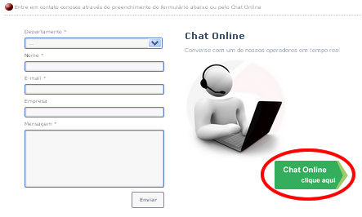
<button id="btn_chat" onclick="openConversation();"></button>

3. ERM – ENTITY RELATIONSHIP MODEL

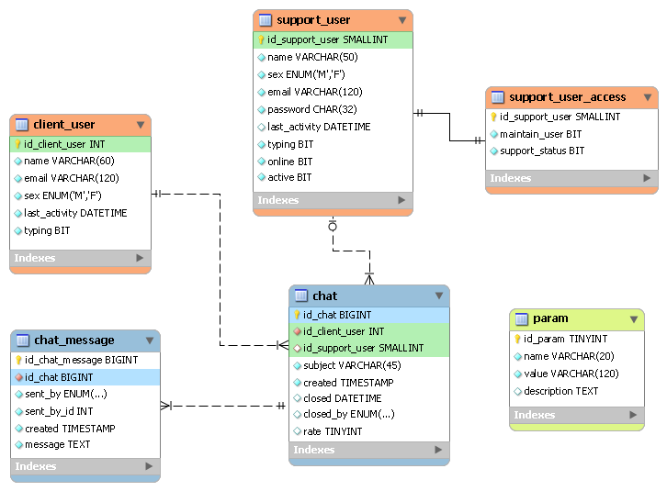

4. translating into other languages

To perform the translation of the chat into other languages just translate the content of the following folders:

"/chat/controllers/*"
"/chat/views/*"
"/chat/public/js/pages/*"

Note: There is a translation into Portuguese ready-made inside the folder "docs", file "português.zip". Just unpack, copy and paste in the folder "chat" and replace all the files and you will have the chat translated into Portuguese.

5. SYSTEM REQUIREMENTS

- PHP 5.2+
  - Extension “pdo”
  - Extension “pdo_mysql”
  - Extension “mod_rewrite”
- MySQL 5.0+
- Modern browsers preferably (It will work with older versions as well)
  - Firefox 35+
  - Chrome 39+
  - Internet Explorer 8+
- JavaScript enabled

6. STANDARD USER ACCESS

To open the restricted area for the support, there is a standard access user. This page can be accessed via the following URL and access data:
http://www.your-website-url.com/chat/login
E-mail: your.email@yourhost.com.br
Password: 1234
Note: After performing the login, be sure to edit this user and change your e-mail.

Once you access the restricted area, you can create other users that may support your clients.

7. CHANGING PARAMETERS (DB)

Open the database and then the table "param".
This table keeps some parameters that you must manually configure according to your preference.
Change the column “value” only.
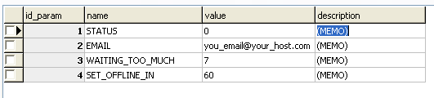

- This is the status of the chat, keep it as “0”.
- This will be the e-mail that receives messages when the chat is offline, enter the e-mail that you prefer.
- This is the time in "minutes" which is considered too much for the customer to wait for having support.
- This is the time in "minutes" that will automatically change the support user status to offline. For example: If you stay more than 60 minutes in inactivity it will be automatically considered offline.

